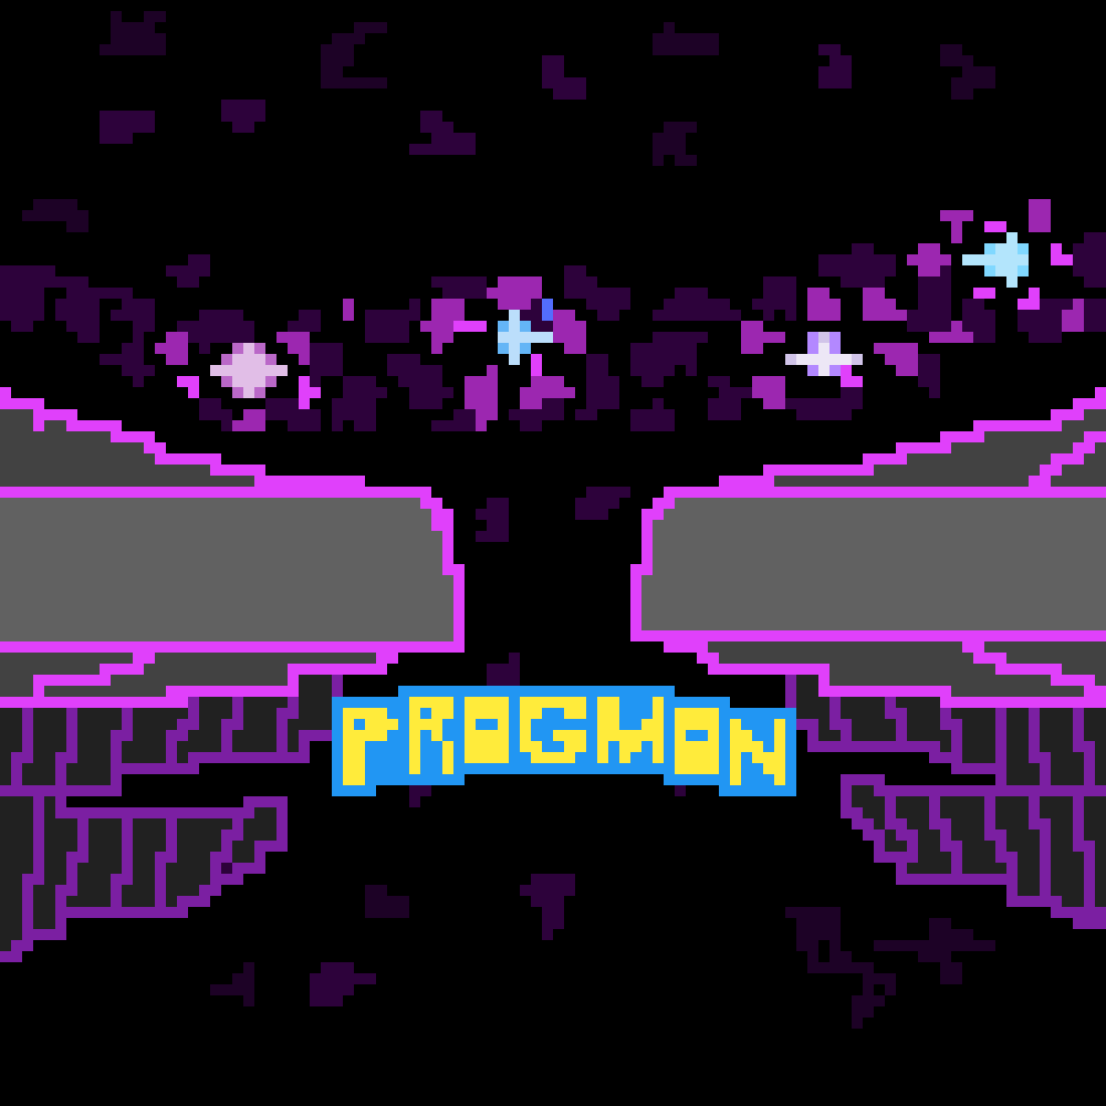

**Progmon**

By *Five Guys*

Jackson Cole Adams, Rob Chirpich, Beau Hodes, Afnan Latif, Qui Phan, Cameron Tomka

Maintenance Plan

First, we will need a list of all required items/persons for our product:

* 3 game developers
* Small business server
* Office rent for our developers
* Running a website for customer support
* Freelance work on website artwork and design
* Ads

Game Developers:

We need game developers to keep our product running smoothly by implementing bug fixes and adding to the product over time for our consumers to enjoy new content and stay engaged with our product. One is not enough for our game as there could randomly be an influx of bugs or issues within the game that is not enough for any single person to handle. Two is better, but to be sure we don’t run into any issues we will start off by hiring three developers to run our product for at least the first year. If we give them an average salary of a start-up game at around $60,000/year we are looking at $180,000/year just for our game developers. We see this as a necessity as there will definitely be bugs within our game that our users will encounter later, along with that we need our developers to incorporate changes and improvements to the game that will be beneficial to our users and game. Therefore, after hiring our game developers our total spending cost for year one thus far is:

TOTAL: $180,000

Small Business Server:

We need a small business server in order to keep our game running on our different user’s accounts. Each user will be able to eventually play other users after our game developers implement online gameplay. For this reason, we need to have these servers to keep track of information of each account. For now, we think a small business server will do just fine for the size of our game as we don’t expect thousands upon thousands of people to try our game within the first year. Although if this does happen, we can for sure increase our server size with the amount of money we make from that. For now, we are planning on paying about $200/month for a small business server. We chose to rent because we don’t have to worry about maintaining the hardware and we can cancel anytime. If we do become a larger company and our game reaches a wider audience, then we will consider buying our own servers. Thus, after one year of upkeep, including cost of our game developers, our spending cost is:

TOTAL: $182,400

Office Rent:

We need to provide our developers somewhere to work as we want them to be able to communicate properly and not work only remotely. Thus, we will provide an office space for them to work and implement changes to the game. Since our developer team is only composed of three individuals, we will pick a smaller space for our team to work so we can save on money.

Assuming we hire locally, we can get an office space in Kansas City for $650/month. We see

this as a need rather than a want because we want our developers to work as a team and be able to communicate with each other on a daily basis. This will help them as it’s already hard enough to work on code with a team, much less not even seeing them in real life and all trying to work on the same code. Thus, after getting office rent, our spending cost will be:

TOTAL: $190,200

Website Domain Rental:

We are going to plan on having our own website in order to taking in complaints, suggesting’s, customer support, and other things from our customers and players. It is important to have a proper form of communication with them because they are paying for our product and expect us to incorporate updates throughout the time that they play and own the game. Fortunately for us, buying a website domain is relatively cheap at only $10. This, our total cost after this will be:

TOTAL: $190,210

Website Designer:

If we are going to own a website, we also are going to need to have it look nice and clean for our users. For this reason, we are going to hire a website designer, so we don’t have to waste our valuable game developers time on doing this. Therefore, we are going to hire a website designer for $75/hour for a total of 30 hours. We want to do this instead because it could take this 3rd party less time to do it as it is, they specialty compared to our game developers who are mostly handing backend and game code. It’s also easier to do this because we don’t have to make our own designs and we can get some cool and creative looking designs that our users will like as well by doing this. After buying a website designer for that price, our total will come to:

TOTAL: $192,460

Ads:

We will need to spend money on ads and we are going to do this simply by using Google Ads. This will cost us around $9,000 per month. It is important to incorporate ads into our plan as we want to reach out to as many people as possible. This will in turn create more revenue for us in the end and we will be able to create a larger game and do what we want to do with it.

Our final total for all the things we will need for the next year is:

**$300,460**